附件
「未來圖書館- 價值、影響、定位研討會」議程
Libraries of the Future - VALUE, INFLUENCE, and POSITIONING Agenda

時間 | 議程
13:00 – 13:20 | 報到  Registration
13:20 – 13:30 | 開幕致詞  Welcome Remarks  柯皓仁教授 Prof. Hao-Ren Ke  國立臺灣師範大學圖書資訊學研究所教授兼圖書館館長  中華民國圖書館學會理事長  University Librarian & Professor, Graduate Institute of Library & Information Studies, National Taiwan Normal University  President, Library Association of the Republic of China (Taiwan)
13:30 – 14:15 | 未來學術圖書館所需的技能和領導力  Skills and Leadership in the Future Academic Library  Mr. Peter Sidorko  香港大學圖書館館長  University Librarian, Hong Kong University  Demands placed on libraries continue to mount as they assume new roles that require flexibility, agility and an overall creative responsiveness. Within this volatile environment, the pressures exerted call for skills, attributes and characteristics that will be new to librarians. This is particularly true in an academic and research environment. This presentation will provide an overview of evolving needs for new skills in academic librarianship and by implication the need for new approaches to leadership in academic libraries. Drawing on twenty years of working with library leadership training (CAUDIT-EDUCAUSE Institute, 2000-2003; The University of Hong Kong Libraries Annual Leadership Institute, 2002-present, and; teaching leadership and management courses at the University of Hong Kong), the speaker will also draw on personal experiences related to those experiences.  引言人；  柯皓仁教授 Prof. Hao-Ren Ke  國立臺灣師範大學圖書資訊學研究所教授兼圖書館館長  中華民國圖書館學會理事長  University Librarian  Professor, Graduate Institute of Library & Information Studies  National Taiwan Normal University  President, Library Association of the Republic of China (Taiwan)
14:15 –15:00 | 圖書館運用人工智慧與機器學習：潛力與可能性  AI & Machine Learning in Libraries: Potentials & Possibilities  Jason Griffey  哈佛大學 Metalab 研究員  Affiliate Researcher, MetaLab at Harvard University  Artificial intelligence and machine learning systems have embedded themselves in nearly aspect of our digital lives. From creation to consumption, information has been forever changed by AI. This is true as well in librarianship, although the largest changes are yet to come. This talk will examine how AI has affected authority of informational resources, and how the next 5-10 years of AI and machine learning will change libraries and librarianship.  Moderator引言人:  陳志銘 教授 Prof. Chih-Ming Chen  教授兼圖書館館長、社會科學資料中心主任  圖書資訊與檔案學研究所  國立政治大學  Library Director and Director of Social Sciences Information Center  Professor, Graduate Institute of Library, Information and Archival Studies  National Cheng Chi University
15:00 – 15:30 | 休息和交流  Break and Networking
15:30 – 16:15 | 新加坡管理大學圖書館如何在研究週期中發揮價值並幫助建立機構聲譽  How can the Library show value in the research cycle and help to build institutional reputation: An example from Singapore Management University  Ms. Pin Pin YEO  新加坡管理大學圖書館學術傳播主任  Head, Scholarly Communication, Singapore Management University Libraries  Libraries face challenges in playing roles and how they can show value in the research cycle of their institution. The presentation will show how the Singapore Management University (SMU) Libraries play a part in the research publications system and how it showcases SMU publications and also provides the full text where possible in the SMU repository called InK. Some examples of how the information is used and what faculty think about having their publications in InK will be shared. The Library is also involved in providing publications metrics.  引言人:  林奇秀教授Chi-Shiou Lin, Ph.D.  國立臺灣大學圖書資訊學系教授兼系主任  Professor & Department Chair, Dept. of Library & Information Science,  National Taiwan University
16:15 – 17:00 | 建構研究數據管理圖書館員學院  Formation of a Research Data Management Librarian Academy  Jean Shipman  Elsevier 全球圖書館關係副總  Vice President, Global Library Relations, Elsevier  A team of librarians are creating a free, online Research Data Management (RDM) Librarian Academy aimed primarily for practicing librarians, but also for researchers to gain knowledge about RDM principles and best practices. The training modules will be available to any one across the globe. The development team includes librarians from Harvard Medical School, Tufts Health Sciences, MCPHS University, Boston University School of Medicine, Northeastern University, Elsevier, and Simmons University. Simmons University will grant continuing education credit for those desiring such. This is a unique partnership between librarians, library educators, and a publisher.  The need for this training was evidenced through interviews and surveys which identified gaps in current training offerings and highlighted what skills librarians and researchers need to contribute to their RDM success. An inventory of existing courses was prepared as well. This presentation will highlight outcomes of the needs assessment and inventory, and it will share proposed training unit content.

「未來圖書館- 價值、影響、定位研討會」
會 議 場 地 交 通 資 訊

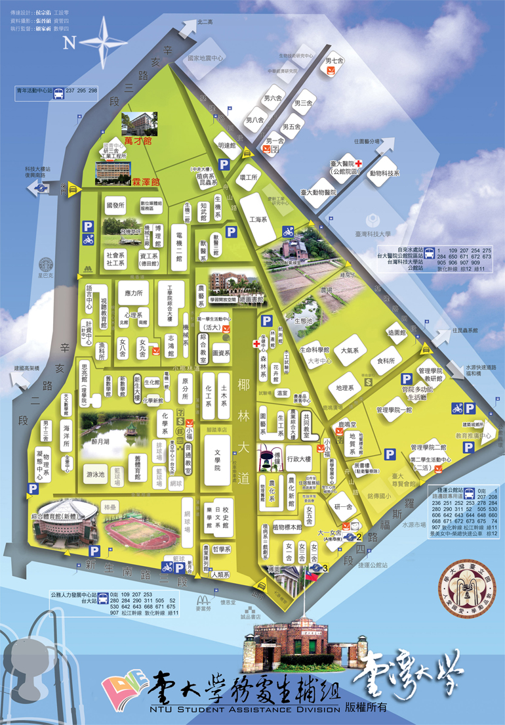

交通資訊：
開車：自辛亥路、復興南路口台灣大學第二校門進入後左手邊第一棟即為霖澤館。
公車：台大資訊大樓站：298。羅斯福路公館站：30、653、74、254、278、643、644、252、251、236、606、291、208、1、510、253、907。由正大門進入台大，新生南路台大站：642、290、505、907、284、253、52、280、311、○南。由西側門進入台大，和平東路復興南路口站：3、72、74、18、52、211、235、284、237、278、15、209、295、626、和平幹線、敦化幹線(下車後走向和平東路二段 96 巷延 96 巷直走約 250 公尺跨過辛亥路即台大後人行側門)
捷運：新店線於「公館站」下車，五號出口直行約八分鐘即可到達；文湖線於「科技大樓站」下車，沿復興南路往南走約 250 公尺進入台大後門(第二校門)
停車：停車問題，依台大相關規定，惟校內停車位不多，仍請多利用捷運。

